Our Irish theme for the next fortnight is An Teilifís and is based on Unit 14 of the Bun go Barr book. Although it is a fortnightly theme, the work will be broken up into weekly blocks.
Please see below a list of new vocabulary that hopefully your child can become familiar with, through practice, over the next two weeks.
Look at the poster below and discuss it using the questions underneath the poster.

Foclóir Nua (New Vocabulary)
- fón rialtán
- fón póca ríomhaire
- físeán méarchlár
- teilifís luchóg
- scáileán raidió
- seastán dlúthdhiosca
- printéir cluasáin

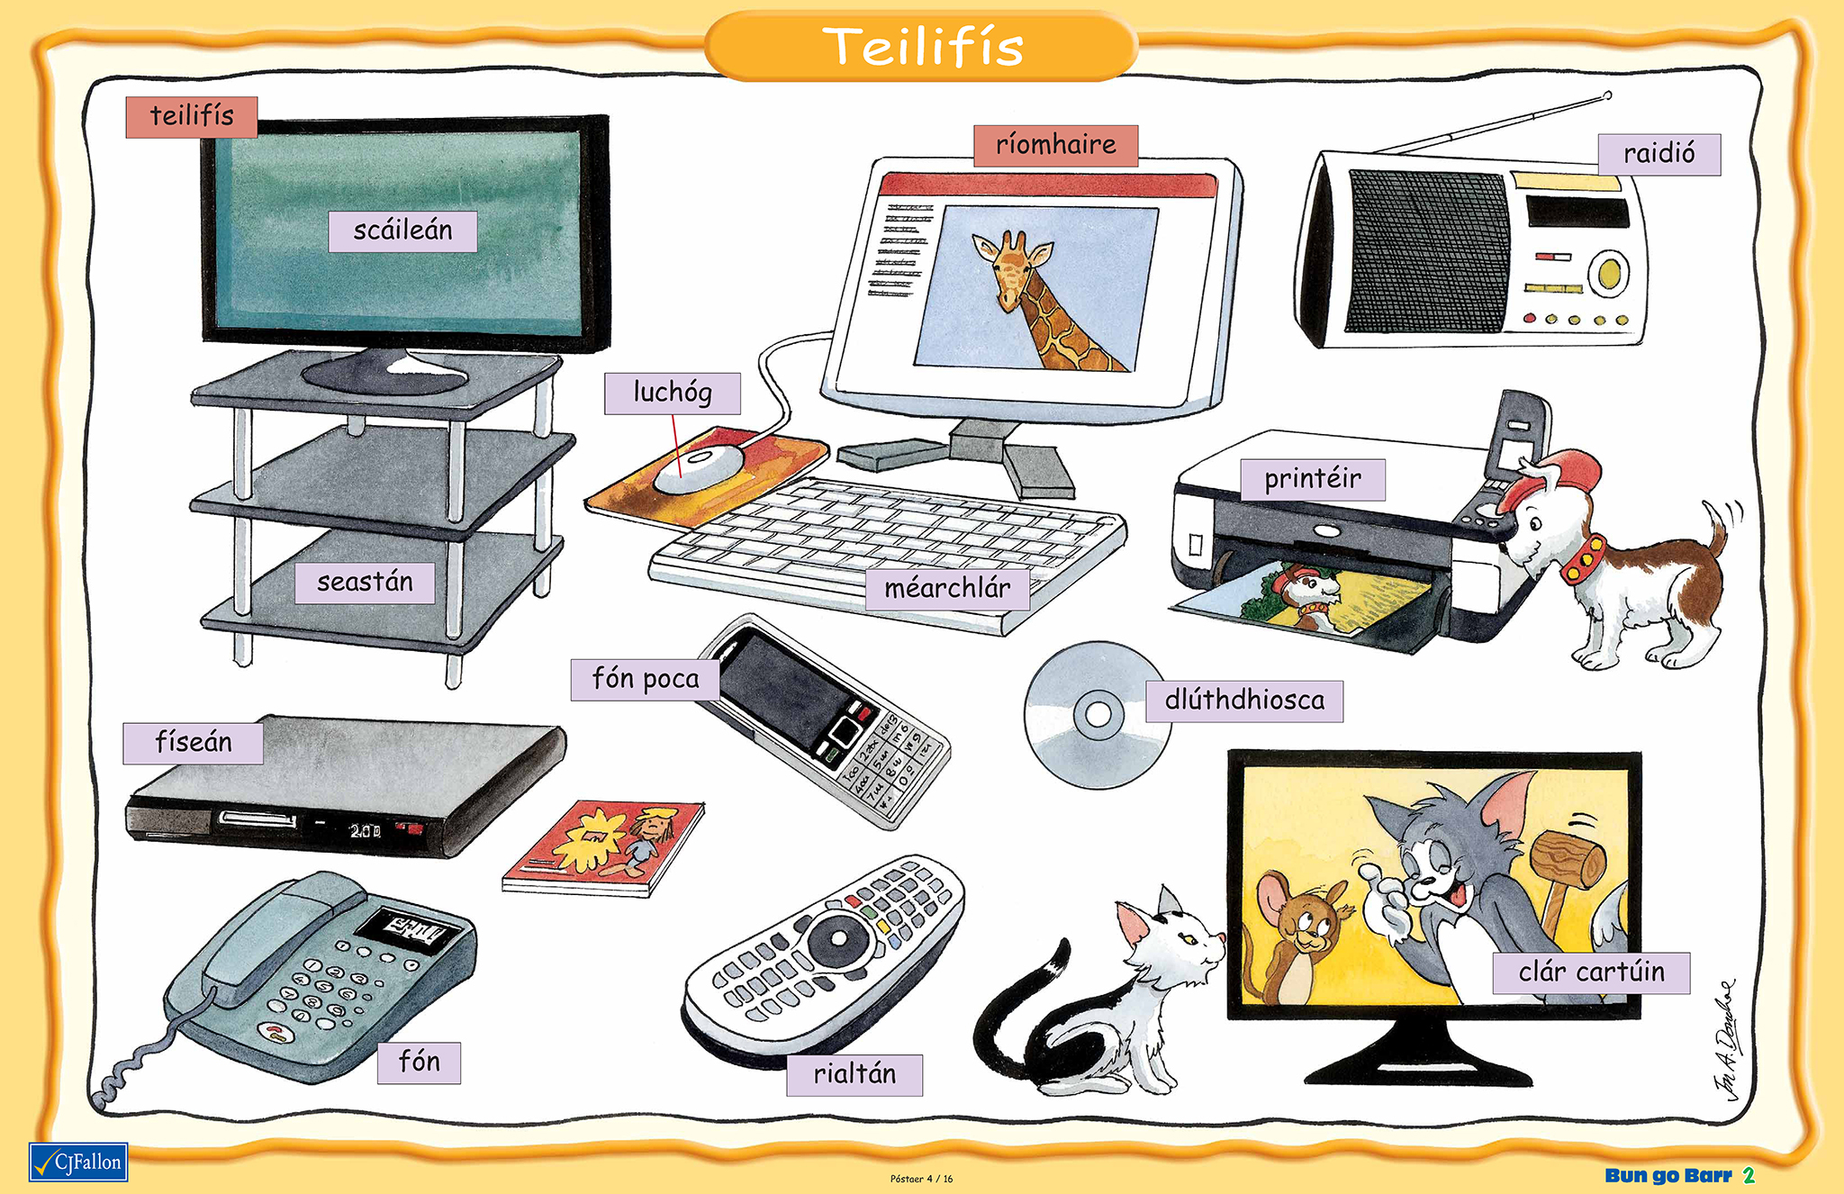

*The above poster can also be accessed online using the following link: https://my.cjfallon.ie/ebooks/ab322/bgb2_post04.jpg

** Repeat the following exercise / question and answer session orally every day for a few minutes at the beginning of your Irish session. Please encourage your child to answer using FULL SENTENCES rather than just giving one-word answers such as tá or níl. You could also reverse roles and give your child the opportunity to be the questioner.

***Apologies if the translations and instructions seem patronising. It’s hard to know how much/little guidance people want so I am erring on the side of caution.

Ceisteanna agus Fócas na Cumarsáide

- Cad é seo? Cad é sin?
What is this?/ What is that?
Sin _____ / Seo ________ .

- Cé / Céard atá sa phictiúr?
What is in the picture?
Tá ______ sa phictiúr.

- Taispeáin dom an scaileán, an teilifís, an luchóg.
Show me the screen, television, mouse.

- An bhfuil ... sa seomra ranga ar scoil?
Is there a ….. in the classroom in school?
Tá / Níl ____ sa seomra ranga ar scoil.

- An bhfuil ... againn anseo sa bhaile?
Do we have a ……. here at home?
Tá / Níl _____ again anseo sa bhaile.

- Cá bhfuil an teilifís?
Where is the television?
Tá an teilifís sa seomra suí / sa chistin / sa seomra leaba.

- An maith leat an teilifís?
Do you like the television?
Is/Ní maith liom an teilifís.

- Cén saghas clár teilifís is fearr leat?
What type of television programme do you prefer?
Is fear liom clár spóirt/ clár dúlra (nature) / clár grinn (comedy) / cartúin etc.

Léitheoireacht (Reading)
Read pages 86 and 87 of Bun go Barr taking 2 sections per day (This is a recommendation only). So for example read sections numbered 1&2 ar an Luan, 3&4 ar an Mháirt etc.

Leathanach 88: READ the questions and WRITE the answers
Leathanach 89: Mar an tseachtain seo chaite - ag cur agus ag freagairt ceisteanna (As last week – asking and answering questions orally)
Leathanach 90: Is féidir leis an páiste ainm an rud a scriobh sios agus pictiúr beag a tharraingt leis. Your child could write the names of 5 or 6 items and draw a picture of each.
Leathanach 91: Tá rann deas beag anseo le Seán Máirtín, is féidir le na páistí an dán sin a léamh nó a fhoghlaim. There is a lovely simple poem here called An Teilfís, The children could try to learn this poem over the course of the week.

I had hoped to buy the Bun go Barr books back from parents at the end of this school year by keeping the books and giving a reduction in book rental for next year of €10 per child. This is in an effort to build up our portfolio of books available to children under the book rental scheme. The children had therefore not written into the books so far this year and had completed all written activities into their copies. If people felt happy to support this initiative, that would be very much appreciated. In this instance, those children will continue to complete written activities into their copies for the remainder of the year, will return their book to the school at the end of the year, and avail of the discount on next year’s book rental cost.
However, I obviously understand if, under the current circumstances, there are people who feel they want to allow their children to write into the books, and needless to say, that is of course your prerogative.
If anybody has any queries about this, please do not hesitate to contact me.

